Google Play Services.

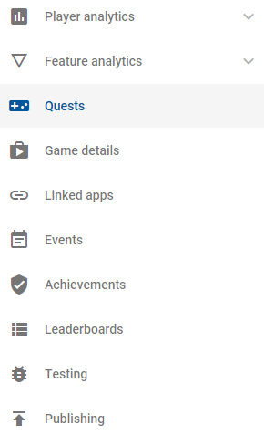

Google Play Services is a collection of APIs offered by Google as a method of interacting and engaging with Android Users, as well as allowing Data Collection and providing easy ways to implement social elements such as multiplayer, leaderboards or achievements into your game.

While Unity offers Unity Analytics, Google’s services can be beneficial for Gaia, especially as we want players to be interacting with our game for a while. By implementing achievements, we can provide players with a sense of progression, even if it’s not specifically shown in game. Achievements using these services come in two categories: Incremental and Normal.

Incremental Achievements aren’t earned immediately. Instead, they are worked towards and show players a progress meter and a percentage towards completion, allowing players to track their own progress. Normal achievements are earned immediately and should be used to reward players for engaging in specific interactions or reaching various milestones.

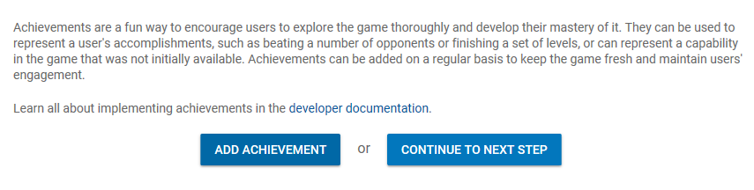

The list of achievements can be updated regularly, and by using Google’s services, we can gain access to ‘Quests’. These are short events that are measured in real-time, where we can provide players with specific goals, such has ‘level up the Style STAT 3 times!’, and by doing so, we can reward players.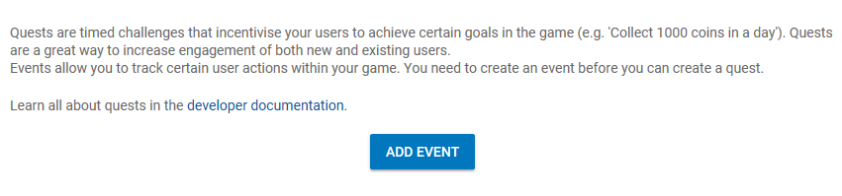

NOTE: The latest version of this plugin no longer supports iOS, so for now, this should be treated as an Android Exclusive Feature.

In order to access this information, we need to first of all download Google Play Games Plugin for Unity. The Files can be located here: <https://github.com/playgameservices/play-games-plugin-for-unity>

Instructions on implementing and using the plugin can be found on the above link.